Latihan SQL

**Petunjuk**

* Gunakan PhpMyAdmin yang terdapat pada komputer Anda atau [PhpMyAdmin versi online](https://demo.phpmyadmin.net/master-config/)
* Masukkan query Anda ke dalam textbox yang telah disediakan
* Screenshoot hasil query Anda sebagai bukti query Anda berhasil dieksekusi

1. Buatlah Tabel transaksi seperti contoh tabel dibawah ini

[CREATE](http://localhost/phpmyadmin/url.php?url=https://dev.mysql.com/doc/refman/5.7/en/create-table.html" \t "mysql_doc) [TABLE](http://localhost/phpmyadmin/url.php?url=https://dev.mysql.com/doc/refman/5.7/en/create-table.html) transaksi(

transaksi\_id INTEGER [NOT](http://localhost/phpmyadmin/url.php?url=https://dev.mysql.com/doc/refman/5.7/en/logical-operators.html%23operator_not) NULL PRIMARY KEY AUTO\_INCREMENT,

kode\_transaksi VARCHAR(10) [NOT](http://localhost/phpmyadmin/url.php?url=https://dev.mysql.com/doc/refman/5.7/en/logical-operators.html%23operator_not) NULL,

tanggal\_transaksi DATE [NOT](http://localhost/phpmyadmin/url.php?url=https://dev.mysql.com/doc/refman/5.7/en/logical-operators.html%23operator_not) NULL,

email\_pelanggan VARCHAR(50) [NOT](http://localhost/phpmyadmin/url.php?url=https://dev.mysql.com/doc/refman/5.7/en/logical-operators.html%23operator_not) NULL,

status\_pembayaran ENUM('lunas', 'belum lunas') [NOT](http://localhost/phpmyadmin/url.php?url=https://dev.mysql.com/doc/refman/5.7/en/logical-operators.html%23operator_not) NULL

);

[INSERT](http://localhost/phpmyadmin/url.php?url=https://dev.mysql.com/doc/refman/5.7/en/insert.html) INTO transaksi (`kode\_transaksi`, `tanggal\_transaksi`, `email\_pelanggan`, `status\_pembayaran`)

[VALUES](http://localhost/phpmyadmin/url.php?url=https://dev.mysql.com/doc/refman/5.7/en/miscellaneous-functions.html%23function_values)

('TRS001', '2021-02-19', 'andi@email.com', 'Lunas'),

('TRS002', '2021-05-02', 'asih@email.com', 'Belum Lunas'),

('TRS003', '2021-06-29', 'budi@email.com', 'Lunas'),

('TRS004', '2021-10-04', 'ari@email.com', 'Belum Lunas');

|  |  |  |  |  |
| --- | --- | --- | --- | --- |
| **transaksi\_id** | **kode\_transaksi** | **tanggal\_transaksi** | **email\_pelanggan** | **status\_pembayaran** |
| 1 | TRS001 | 2021-02-19 | andi@email.com | Lunas |
| 2 | TRS002 | 2021-05-02 | asih@email.com | Belum Lunas |
| 3 | TRS003 | 2021-06-29 | budi@email.com | Lunas |
| 4 | TRS004 | 2021-10-04 | ari@email.com | Belum Lunas |

**Screenshoot Hasil Query**

1. Tampilkan Nama dan Alamat Pelanggan dengan status pembayaran belum lunas

[SELECT](http://localhost/phpmyadmin/url.php?url=https://dev.mysql.com/doc/refman/5.7/en/select.html) pelanggan.nama, pelanggan.alamat, transaksi.status\_pembayaran

FROM `transaksi`

INNER JOIN pelanggan

ON transaksi.email\_pelanggan = pelanggan.email

WHERE status\_pembayaran='Belum Lunas';

**Screenshoot Hasil Query**

1. Perbaharui status pembayaran transaksi dengan kode transaksi TRS004 menjadi Lunas

[UPDATE](http://localhost/phpmyadmin/url.php?url=https://dev.mysql.com/doc/refman/5.7/en/update.html) `transaksi`

[SET](http://localhost/phpmyadmin/url.php?url=https://dev.mysql.com/doc/refman/5.7/en/set.html) `status\_pembayaran`='Lunas'

WHERE `kode\_transaksi`='TRS004';

**Screenshoot Hasil Query**

1. Tampilkan jumlah pelanggan dengan status pembayaran Lunas

[SELECT](http://localhost/phpmyadmin/url.php?url=https://dev.mysql.com/doc/refman/5.7/en/select.html) [COUNT](http://localhost/phpmyadmin/url.php?url=https://dev.mysql.com/doc/refman/5.7/en/aggregate-functions.html%23function_count)(`transaksi\_id`) AS Jumlah, `status\_pembayaran` AS Keterangan

FROM `transaksi`

WHERE `status\_pembayaran`='Lunas';

**Screenshoot Hasil Query**

1. Buatlah sebuah Tabel detail\_transaksi seperti contoh dibawah ini

[CREATE](http://localhost/phpmyadmin/url.php?url=https://dev.mysql.com/doc/refman/5.7/en/create-table.html) [TABLE](http://localhost/phpmyadmin/url.php?url=https://dev.mysql.com/doc/refman/5.7/en/create-table.html) detail\_transaksi (

detail\_transaksi\_id INTEGER [NOT](http://localhost/phpmyadmin/url.php?url=https://dev.mysql.com/doc/refman/5.7/en/logical-operators.html%23operator_not) NULL AUTO\_INCREMENT,

kode\_transaksi VARCHAR(10) [NOT](http://localhost/phpmyadmin/url.php?url=https://dev.mysql.com/doc/refman/5.7/en/logical-operators.html%23operator_not) NULL,

sku VARCHAR(50) [NOT](http://localhost/phpmyadmin/url.php?url=https://dev.mysql.com/doc/refman/5.7/en/logical-operators.html%23operator_not) NULL,

item INTEGER [NOT](http://localhost/phpmyadmin/url.php?url=https://dev.mysql.com/doc/refman/5.7/en/logical-operators.html%23operator_not) NULL,

harga\_total\_per\_produk DECIMAL(7.2) [NOT](http://localhost/phpmyadmin/url.php?url=https://dev.mysql.com/doc/refman/5.7/en/logical-operators.html%23operator_not) NULL,

PRIMARY KEY (detail\_id) );

[INSERT](http://localhost/phpmyadmin/url.php?url=https://dev.mysql.com/doc/refman/5.7/en/insert.html) INTO `detail\_transaksi`

(`kode\_transaksi`, `sku`, `item`, `harga\_total\_per\_produk`)

[VALUES](http://localhost/phpmyadmin/url.php?url=https://dev.mysql.com/doc/refman/5.7/en/miscellaneous-functions.html%23function_values)

('TRS001','PRD023',5,5000),

('TRS001','PRD024',2,6000),

('TRS001','PRD025',3,33000),

('TRS001','PRD026',1,45000),

('TRS002','PRD023',5,5000),

('TRS002','PRD024',5,15000),

('TRS003','PRD025',2,22000),

('TRS004','PRD026',2,90000);

|  |  |  |  |
| --- | --- | --- | --- |
| **kode\_transaksi** | **Sku** | **item** | **harga\_total\_per\_produk** |
| TRS001 | PRD023 | 5 | 5000 |
| TRS001 | PRD024 | 2 | 6000 |
| TRS001 | PRD025 | 3 | 33000 |
| TRS001 | PRD026 | 1 | 45000 |
| TRS002 | PRD023 | 5 | 5000 |
| TRS002 | PRD024 | 5 | 15000 |
| TRS003 | PRD025 | 2 | 22000 |
| TRS004 | PRD026 | 2 | 90000 |

**Screenshoot Hasil Query**

1. Tampilkan semua nama produk yang dibeli oleh Andi

SELECT `produk`.`nama` AS NamaProduk, `produk`.`sku` FROM `produk` WHERE `produk`.`sku` IN (

SELECT `detail\_transaksi`.`sku`

FROM `detail\_transaksi`

WHERE `detail\_transaksi`.`kode\_transaksi` IN (

SELECT `transaksi`.`kode\_transaksi`

FROM `transaksi`

WHERE `transaksi`.`email\_pelanggan` IN (

SELECT `pelanggan`.`email` FROM pelanggan WHERE `pelanggan`.`nama`="Andi"

)

)

)

**Screenshoot Hasil Query**

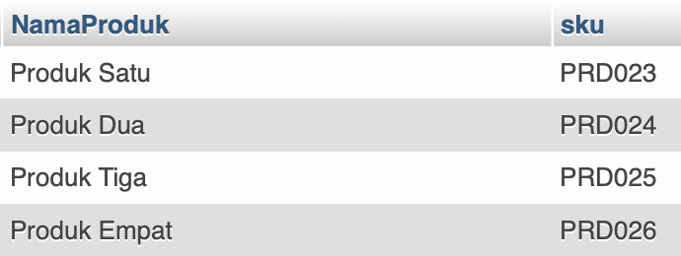

1. Tampilkan jumlah produk yang dibeli oleh Budi

SELECT COUNT(`detail\_transaksi`.`sku`) AS JumlahProduk, SUM(`detail\_transaksi`.`item`) AS TotalBarang

FROM `detail\_transaksi`

WHERE `detail\_transaksi`.`kode\_transaksi` IN (

SELECT `transaksi`.`kode\_transaksi`

FROM `transaksi`

WHERE `transaksi`.`email\_pelanggan` IN (

SELECT `pelanggan`.`email` FROM pelanggan WHERE `pelanggan`.`nama`="Budi"

)

)

**Screenshoot Hasil Query**



1. Tampilkan total harga yang dibayarkan oleh Asih

SELECT COUNT(`detail\_transaksi`.`sku`) AS JumlahProduk, SUM(`detail\_transaksi`.`item`) AS TotalBarang, SUM(`detail\_transaksi`.`harga\_total\_per\_produk`) AS TotalBayar

FROM `detail\_transaksi`

WHERE `detail\_transaksi`.`kode\_transaksi` IN (

SELECT `transaksi`.`kode\_transaksi`

FROM `transaksi`

WHERE `transaksi`.`email\_pelanggan` IN (

SELECT `pelanggan`.`email` FROM pelanggan WHERE `pelanggan`.`nama`="Asih"

)

)

**Screenshoot Hasil Query**



1. Tampilkan total transaksi sepanjang tahun 2021

SELECT

COUNT(`detail\_transaksi`.`kode\_transaksi`) AS TotalTransaksi2021,

SUM(`detail\_transaksi`.`harga\_total\_per\_produk`) AS TotalTransaksi2021

FROM `detail\_transaksi` WHERE `detail\_transaksi`.`kode\_transaksi` IN

(

SELECT `transaksi`.`kode\_transaksi` FROM `transaksi` WHERE

YEAR(`transaksi`.`tanggal\_transaksi`)='2021'

)

**Screenshoot Hasil Query**



1. Tampilkan nama pelanggan terurut berdasarkan transaksi paling besar

SELECT

`pelanggan`.`nama` AS Nama,

COUNT(`detail\_transaksi`.`item`) AS JumlahItem,

SUM(`detail\_transaksi`.`harga\_total\_per\_produk`) AS TotalTransaksi

FROM `pelanggan`

JOIN `transaksi`

ON `pelanggan`.`email`=`transaksi`.`email\_pelanggan`

JOIN `detail\_transaksi`

ON `transaksi`.`kode\_transaksi`=`detail\_transaksi`.`kode\_transaksi`

GROUP BY `pelanggan`.`nama`

ORDER BY TotalTransaksi DESC

**Screenshoot Hasil Query**

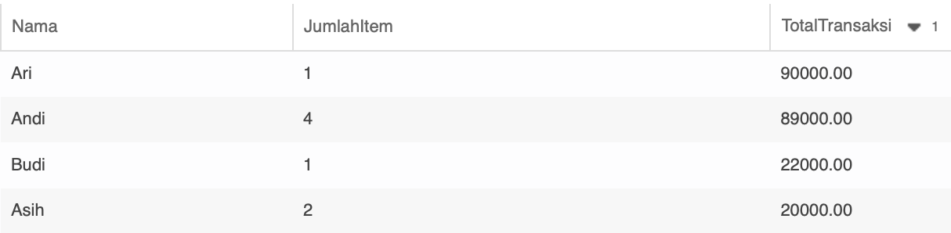

1. Tampilkan nama produk terlaris

SELECT

`produk`.`nama` AS NamaProduk,

SUM(`detail\_transaksi`.`item`) AS JumlahItemTerjual

FROM `produk`

JOIN `detail\_transaksi`

ON `produk`.`sku`=`detail\_transaksi`.`sku`

GROUP BY `produk`.`nama`

ORDER BY JumlahItemTerjual DESC

**Screenshoot Hasil Query**

**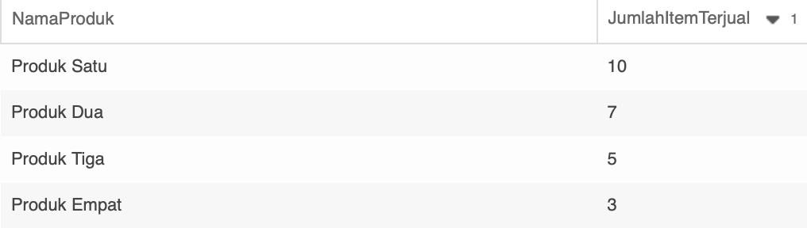**

1. Tampilkan nama produk yang tidak pernah dibeli oleh pelanggan

SELECT

`produk`.`nama` AS ProdukBelumPernahTerjual,

`produk`.`sku` AS SKU

FROM `produk`

WHERE `produk`.`sku`

NOT IN (

SELECT `detail\_transaksi`.`sku`

FROM `detail\_transaksi`

)

**Screenshoot Hasil Query**

